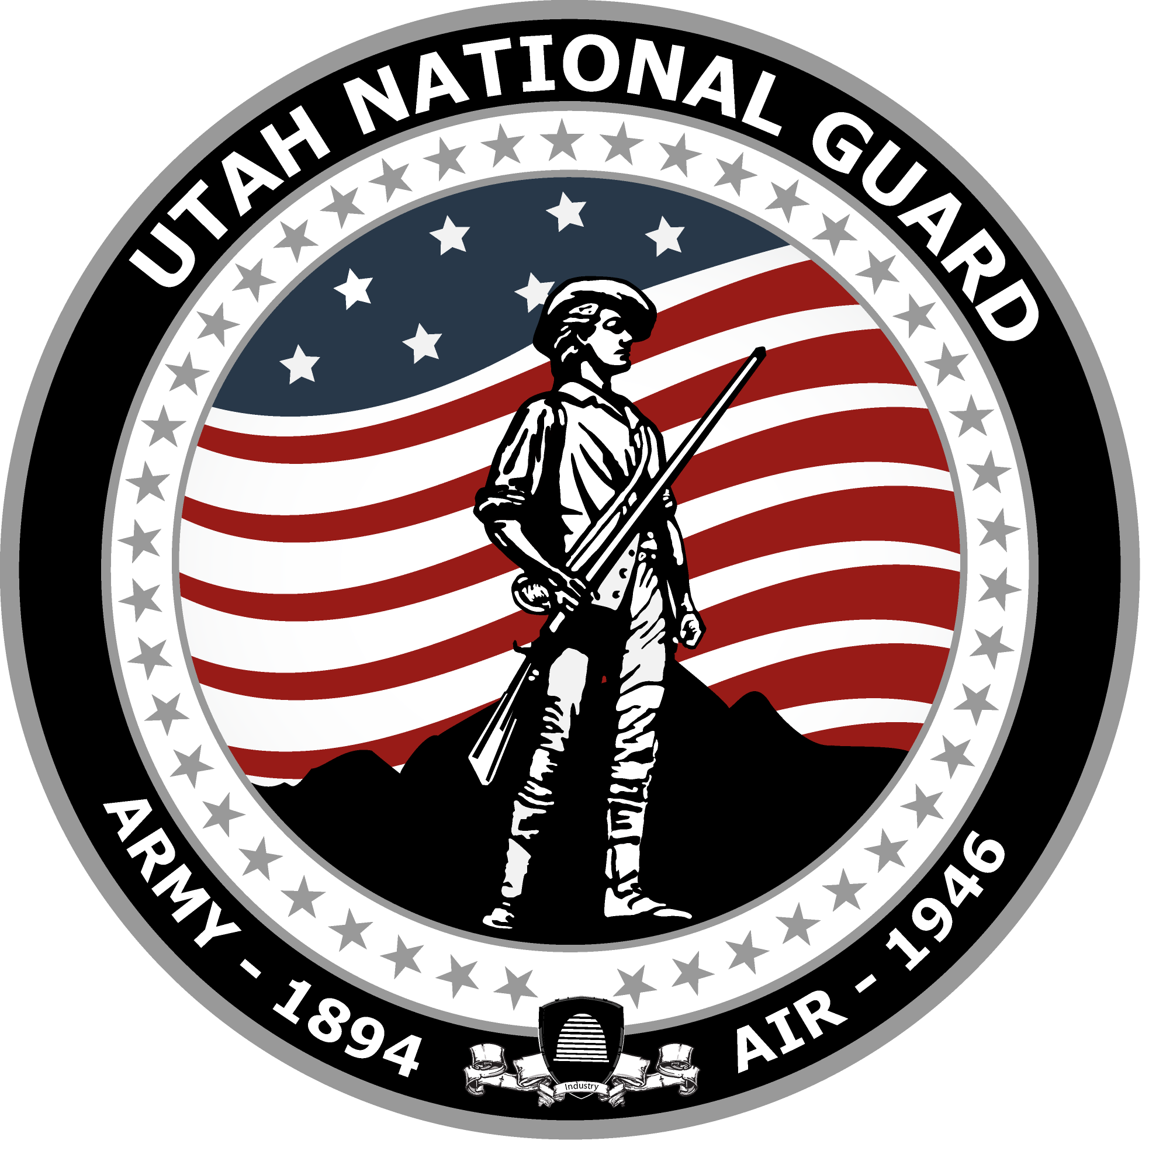
Utah National Guard
HISTORY HIGHLIGHT
Dec 2022

40th Division, World War II

December 7, 1941, “A Date Which Will Live In Infamy”
Germany’s aggressive posture and expansion into Europe in the late 1930s made evident the U.S. was not equipped to handle the growing threat of war. The nation was still reeling from the terrible economic woes created by the Great Depression and the nation’s budget was tight. To meet the threat, Congress voted to increase the defense budget and in May of 1940, the president called the National Guard into federal service. Members of the Utah National Guard answered the call. More than 4,000 enlisted men and 150 officers headed to their armories for activation and said goodbye to their loved ones.  Many Utah Guard members were assigned to the 40th Division, which was a mixed division consisting of Utah, California, and Nevada National Guard members. Their initial task was to complete a year of training at Camp San Luis Obispo in California, followed by service overseas.  After completing their training, Soldiers of the 145th Field Artillery Regiment, 2nd Battalion were loaded onto a troop transport and began their journey from San Francisco to the Philippines in order to shore up the island’s defenses. They never made it…  On a calm December morning, only a few hundred miles away from their transport sailing in the Pacific, a surprise attack launched by the Japanese Navy against the U.S. fleet in Pearl Harbor was underway. The attack changed the course of history, and the course of the ship carrying the 145th.  On December 8, 1941, the formal declaration of war had been made and the threat of a Japanese invasion of the mainland U.S. was very real. To meet the potential invasion, the orders of the 40th had been changed to national defense. The 40th, and the 145th, would spend the next several months defending the shores of California before they were moved to the defense of the Hawaiian Islands in late 1942. |  | 222nd Field Artillery Battalion  The 222nd Field Artillery Battalion distinguished itself during the fighting at Luzon, Panay and Negros.  In April of 1945, the 222nd was the main source of support for the 40th Division. At the end of the Negros campaign, they averaged more than 200 rounds fired per day with a total of more than 13,000 shells fired during 806 missions.  The 222nd found itself a target for nightly Japanese infiltration raids but fought bravely on each occurrence. During one raid, the members of the 222nd fended off a fierce attack from 30 Japanese soldiers with only a few allied casualties and damaged equipment.  The damaged equipment was repaired and back in service the next day.
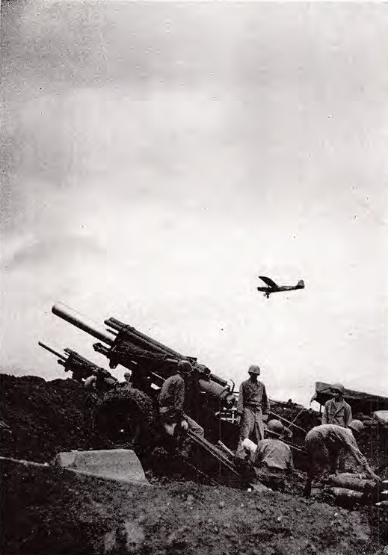
Observation plane flies above the battlefield a aiding the 155mm cannon manned by m members of the 222nd Field Artillery Battalion Batt laying down fire in support of operations on I Hill 3155, named “Dolan Hill”

40th Infantry Division, WWII

December 7, 1941, “A Date Which Will Live In Infamy”
The 40th would continue its defensive mission in Guadalcanal in December of 1943 and then in New Britain in April of 1944.  In March of 1945, the 40th would finally see its first combat of the war. Their assignment, to aid in the invasion of Panay and Negros located in the Philippine Islands.  After months of planning and troop movement, the 40th arrived at the staging point. At 0930 on March 18th, after a short naval bombardment, the invasion began. The main assault encountered little opposition as units made their way to their assigned objectives. However, as the fighting moved inland, increased resistance was encountered leading to many notable battles, one was the battle of Dolan Hill.  The 222nd Field Artillery Battalion, comprised mostly of Utah National Guard Soldiers, would play a pivotal role in the battle. |  |  | The battle of Dolan Hill, named after the first officer to fall in the attack, was a key prominent terrain feature and covered allied approaches in multiple areas. In order to advance, the hill had to fall. The next several days were chalked full of brutal fighting. The advance moved slowly due to an entrenched enemy laying down heavy sustained fire and difficult terrain. Eventually, after waves of artillery bombardment from the 222nd, close-air support, and valiant fighting, the 40th crested the hill and claimed the objective.  At the end of the Panay and Negros campaigns, more than 4,000 enemy Soldiers had been killed or captured and members of the 40th received more than 100 varying medals and citations.  Sources:  The 40th Infantry Division, The years of World War II, 1 December 1941 to 7 April 1946.  Roberts, Richard. Legacy, History of the Utah National Guard. 2003.
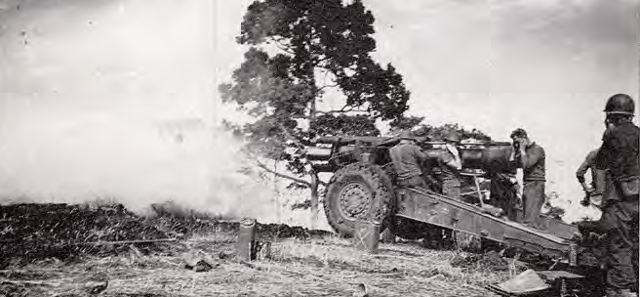
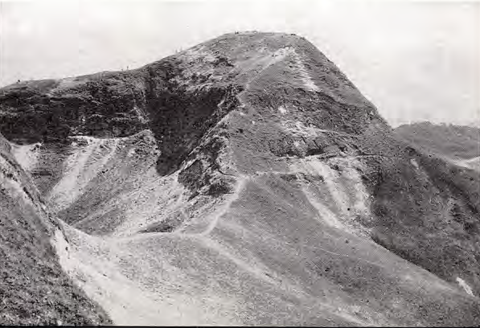 | Members of the 222nd Field Artillery Battalion use their 155mm howitzer as a “sniper rifle” in order to penetrate enemy defenses dug into the hillside. This tactic was used repeatedly during the Panay and Negros campaign due to its effectiveness over indirect fire.

